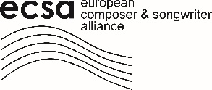
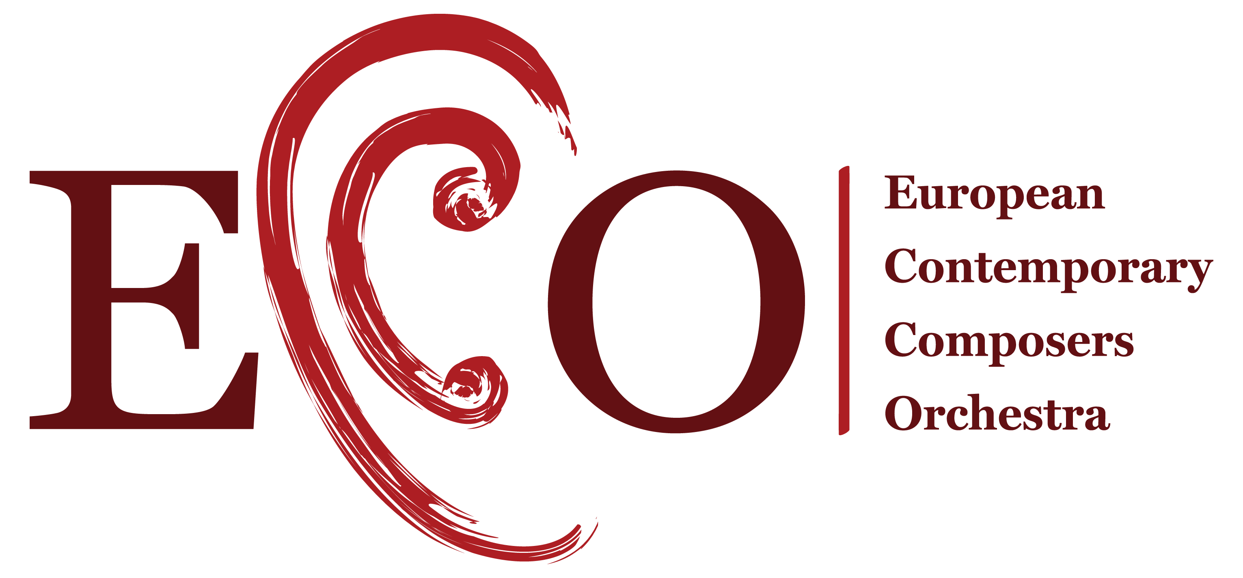

ECCO ENTRY FORM – Brussels 2022

When submitting an entry, we kindly ask that you fill in the below form. Please kindly note there is a maximum of 3 submissions per country – it is for the societies of the said country to decide amongst themselves in order to agree on the scores that shall be presented.
- Country of submission: Click here to enter text.
- Members’ organisations in charge of the selection: Click here to enter text.
- Number of entries: Choose an item.
- Detail entries below (see table):
 | CODE WORD | DURATION | ANY REMARKS
1 | Click here to enter text. | Click here to enter text. | Click here to enter text.
2 | Click here to enter text. | Click here to enter text. | Click here to enter text.
3 | Click here to enter text. | Click here to enter text. | Click here to enter text.

- Please make sure the following is also annexed to the submission:
  - Score (in pdf format without original title)
  - Recording of the entry (MP3 format only)
- Please make sure the following is submitted in case of selection at 28 July 2022 the latest:
  - Biography of the composer
  - Contact information of the composer
  - Photo of the composer (with credit information and authorization to use)
  - Parts of the score
  - Programme notes
- Contact details of the person responsible for the administration of the submission:
Click here to enter text.
Signature and Date:

